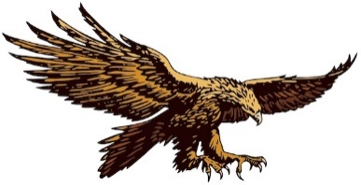
Natural History Society of South Australia Inc
now trading as
Wombats SA
ABN 20 375 644 548

Donation Form – 2024
Your contribution is vital to the on-going success of our reserves and our work to protect and preserve the native flora and fauna of Australia – not the least of which are our Southern Hairy-nosed Wombats.
We are grateful you’ve chosen to include Wombats SA in your list of supported organisations.
Please complete this form in BLOCK LETTERS.
Name: |  | Date:
Address:
Suburb/town: | State: | Postcode:
Telephone: | Mobile:
Email (for your receipt, news & updates):
I would like to support the work of Wombats SA with a one-off donation.  (Donations of $2.00 or more are tax deductible.) |  | $
TOTAL: ☐ Cash ☐ Cheque ☐ EFT/Direct Debit ☐ PayPal (see below) |  | $
Please include your PayPal receipt or bank EFT/Direct Debit number (for online transactions): |  | #

Payment instructions. Please do not send cash through the post.
CHEQUES should be made payable to the "Natural History Society of SA" and posted to the address below.
ONLINE TRANSACTIONS: Please fill out this form including the total amount and the transaction number (see above). This completed form can then be scanned and emailed to treasurer@wombatssa.org.au or posted to the address below.
- PayPal – pay with your credit card using our PayPal facility at https://wombatssa.org.au/ . (A PayPal account is not necessary. Please be aware this incurs a fee that Wombats SA must then pay PayPal for this service.)
- EFT/Direct Bank Deposit: Account name: Natural History Society of SA Inc
BSB: 105-900
Account number: 951531440
[For bank transfers made from outside Australia – SWIFT Bank Identifier Code (BIC): SGBLAU2S]
Please complete this form; then post or scan and email to:
Wombats SA, PO Box 410, BLACKWOOD SA 5051, AUSTRALIA or email treasurer@wombatssa.org.au .

