 | Natural History Society of South Australia Inc  trading as  Wombats SA  AGM 2022: FORM OF PROXY | 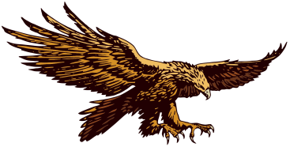

I, the undersigned, ________________________________________________________________________ (print name)
of _______________________________________________________________________________________________ (address)
being a financial Member of Wombats SA / the Natural History Society of South Australia Inc entitled to cast my vote for the decisions made at General Meetings of the Wombats SA,
hereby appoint __________________________________________________________ (name of appointed person)
of _______________________________________________________________________________________________ (address)
or failing him/her ___________________________________________________________ (name of second person)
of _______________________________________________________________________________________________ (address)
as my proxy to vote on my behalf at the meeting of Wombats SA to be held at 6:00pm on the 11th May 2022 and at any adjournment of that meeting. My proxy may vote as he/she thinks (see below).*

Signature______________________________________________________ Date _____________________________________

* Alternatively, if you wish to instruct your proxy, this sentence should be deleted and replaced by:

Return this signed Proxy to the Secretary of Wombats SA not later than 24 HOURS BEFORE the time of the above General Meeting in hard copy sent to Wombats SA Secretary, PO Box 410, BLACKWOOD SA 5051, or a scanned copy sent by email to info@wombatssa.org.au.

