 | Natural History Society of South Australia Inc  trading as  Wombats SA  Nomination Form for NHSSA Management Committee Member Position 2020 | 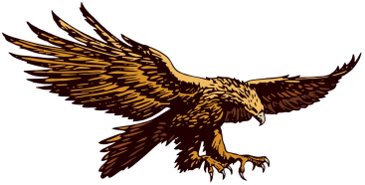
(Please print and sign)

No more than ten positions for Management Committee members are to be filled for one year until the next AGM. Executive Members of the Management Committee are to be elected from within those Members forming the Management Committee at their first meeting following the AGM on 21st May 2020.

I nominate |  | (nominee) as a Management Committee Member.
Nominator |  | Signed
Seconded |  | Signed
I (name of nominee) |  | accept the nomination above.
Signed (nominee) |  | Date

PLEASE NOTE: NOMINATIONS TO BE RECEIVED BACK BY 14th MAY 2020.
Post to NHSSA Secretary, PO Box 410, BLACKWOOD SA 5051 or scan & send to: info@nhssa.com.au.
The list will be posted on the website (nhssa.com.au) one week before the AGM and a copy provided at the AGM.
All nominators, seconders and nominees must be financial members of the NHSSA Inc.

Natural History Society of South Australia Inc
trading as
Wombats SA
Nomination Form for NHSSA Management Committee Member Position 2020
(Please print and sign)

No more than ten positions for Management Committee members are to be filled for one year until the next AGM. Executive Members of the Management Committee are to be elected from within those Members forming the Management Committee at their first meeting following the AGM on 21st May 2020.

I nominate |  | (nominee) as a Management Committee Member.
Nominator |  | Signed
Seconded |  | Signed
I (name of nominee) |  | accept the nomination above.
Signed (nominee) |  | Date

PLEASE NOTE: NOMINATIONS TO BE RECEIVED BACK BY 14th MAY 2020.
Post to NHSSA Secretary, PO Box 410, BLACKWOOD SA 5051 or scan & send to: info@nhssa.com.au.
The list will be posted on the website (nhssa.com.au) one week before the AGM and a copy provided at the AGM.
All nominators, seconders and nominees must be financial members of the NHSSA Inc.

